Modular Wind Turbine

Background

Horizontal axis turbines with exposed blades are installed at heights of 80+ meter for large capacity systems (1 MW+), the same systems are scaled down to use for small capacity, however these systems are not suitable at low wind speeds and not safe for operation owing to open rotating blades. Vertical axis turbines cannot be scaled to increase power output, and have maintenance issues since the wind load is not balanced across the rotor.

Abstract of Invention

Residential areas such as cities, suburbs have lower wind velocity. Moreover, these areas are not feasible for open blade wind power systems due to safety issues. The new concept is a enclosed blade system which leverages venturi effect to take up large quantities of air to increase the velocity for power generation. The new concept is a more efficient and higher capacity system for same footprint as compared to existing wind energy systems. In addition, the system is stackable such that numerous units can be installed vertically on a single column making it easy to install in a DIY way which also eliminates most of the cost of installation.

Summary of Invention

- All present wind turbines are designed for a particular wind velocity. It works from the lower cutoff to upper cutoff velocity. But once designed, the design velocity remains constant
- The diameter of the rotors are constant and the design point is where the output of the wind turbine maximum
- In urban areas of areas of lower altitudes, the wind velocity is different at different locations. The user is forced to use a wind turbine designed for some other wind velocity than the local feasible velocity. This leads to non optimal power outputs

Detailed Working

Wind Inlet

- 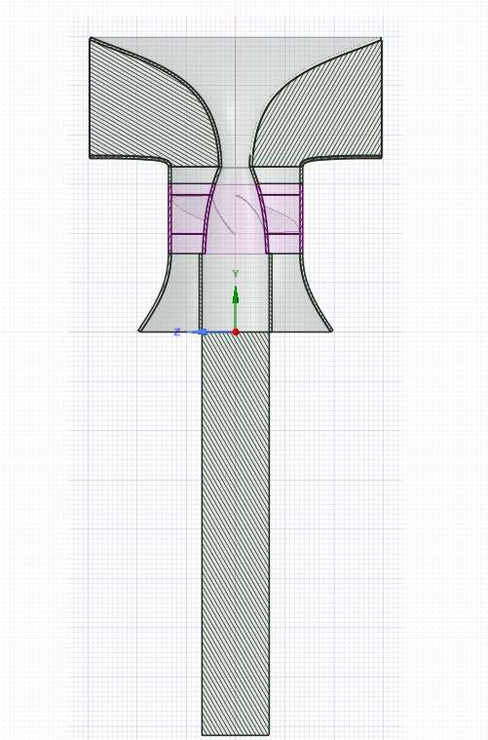The image shows the pole mounted modular wind turbine cross section
- Wind enters through the inlet section and is directed to the turbine section through a convergent channel
- The convergent channel increases the air velocity to match the designed velocity of the turbine (where the efficiency and performance of the turbine is maximum)

Wind Outlet

Rotating Turbine Blades

Detailed Calculations
Velocity, V1 = 1 m/sec

- The flow area refers to the area of flow through the turbine
Area, A1
section. This area is constant
- Refer Fig. 1. For case the turbine is designed for vf = 5 m/sec. In case when V1 = 1 m/sec. Ratio of inlet area : flow area -> A1/Af = 5. In this case:-
- Mass_flow @ A1 = Mass_flow @ Af
  - Thus, A1 x V1 = Af x Vf (continuity equation)
  - Hence, Vf = A1 x V1 / Af = 5 x 1 = 5 m/sec. Thus the design
velocity is achieved when inlet velocity is 1 m/sec
- In case inlet velocity is V1 = 0.5 m/sec (fig. 2):-
  - Vf = 5 x 0.5 = 2.5 m/sec. In case the area A1 was kept constant,
the flow at the turbine section would have now reduced resulting
Flow Area, Af

Velocity, V1 = 0.5 m/sec
Area, A2

Figure 1

in reduced and inefficient power output
  - Now in case we double the area A2 = 2 x A1, we get
  - Vf = A2 x V1 / Af = 2 x 5 x 0.5 = 5 m/sec
  - Thus in this case by increasing the area of inlet we can match the velocity required at the turbine section to the desired design velocity.
Flow Area, Af

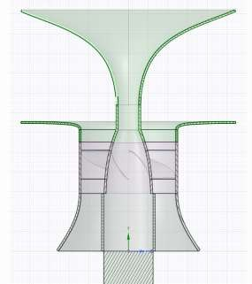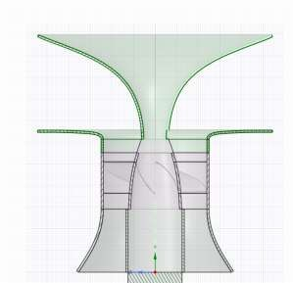
Figure 2

Advantages of Invention
- More efficient and capacity compared to existing systems
- Safe operating wind energy system
- Easy to install
- Scalable and stackable on top of each other
- Designed for low wind speeds suitable for residential areas,

